**i**

**Batch: B4 Roll No.: 16010122221**

**Experiment / assignment / tutorial No.6**

**Grade: AA / AB / BB / BC / CC / CD /DD**

**Signature of the Staff In-charge with date**

|  |
| --- |
| **TITLE: Implementation of LRU Page Replacement Algorithm.** |

**AIM:** The LRU algorithm replaces the least recently used that is the last accessed memory block from the user.

**______________________________________________________________________**

**Expected OUTCOME of Experiment: (Mention CO/CO’s attained here)**

**___________________________________________________________________**

**Books/ Journals/ Websites referred:**

1. Carl Hamacher, Zvonko Vranesic and Safwat Zaky, “Computer Organization”, Fifth Edition, TataMcGraw-Hill.
2. William Stallings, “Computer Organization and Architecture: Designing for Performance”, Eighth Edition, Pearson.

**_____________________________________________________________________**

**Pre Lab/ Prior Concepts:**

It follows a simple logic, while replacing it will replace that page which has least recently used out of all.

a) A hit is said to be occurred when a memory location requested is already in the cache.

b) When cache is not full, the number of blocks is added.

c) When cache is full, the block is replaced which is recently used

**Algorithm:**

1. Start
2. Get input as memory block to be added to cache
3. Consider an element of the array
4. If cache is not full, add element to the cache array
5. If cache is full, check if element is already present
6. If it is hit is incremented
7. If not, element is added to cache removing least recently used element
8. Repeat step 3 to 7 for remaining elements
9. Display the cache at very instance of step 8
10. Print hit ratio
11. End

**Example:**

#include<stdio.h>

main()

{

int q[20],p[50],c=0,c1,d,f,i,j,k=0,n,r,t,b[20],c2[20], hit;

float fh;

printf("Enter number of frames:- ");

scanf("%d",&f);

printf("Enter number of pages:- ");

scanf("%d",&n);

printf("Enter the reference string:- ");

for(i=0;i<n;i++)

scanf("%d",&p[i]);

q[k]=p[k];

printf("\n\t%d\n",q[k]);

c++;

k++;

for(i=1;i<n;i++)

{

c1=0;

for(j=0;j<f;j++)

{

if(p[i]!=q[j])

c1++;

}

if(c1==f)

{

c++;

if(k<f)

{

q[k]=p[i];

k++;

for(j=0;j<k;j++)

printf("\t%d",q[j]);

printf("\n");

}

else

{

for(r=0;r<f;r++)

{

c2[r]=0;

for(j=i-1;j<n;j--)

{

if(q[r]!=p[j])

c2[r]++;

else

break;

}

}

for(r=0;r<f;r++)

b[r]=c2[r];

for(r=0;r<f;r++)

{

for(j=r;j<f;j++)

{

if(b[r]<b[j])

{

t=b[r];

b[r]=b[j];

b[j]=t;

}

}

}

for(r=0;r<f;r++)

{

if(c2[r]==b[0])

q[r]=p[i];

printf("\t%d",q[r]);

}

printf("\n");

}

}

}

printf("\nThe no of page faults is:- %d",c);

hit = n - c;

printf("\nThe no of page hits is:- %d",hit);

}

OUTPUT :

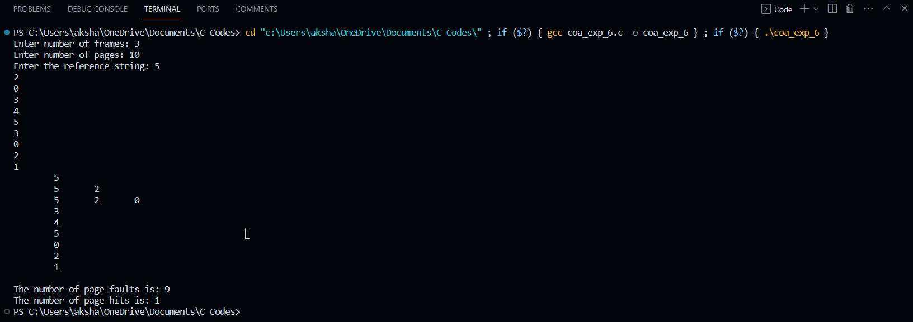

**Post Lab Descriptive Questions**

**1. Define hit rate and miss ratio?**

**Hit Rate :** The chief measurement of a cache, which is the percentage of all accesses that are satisfied by the data in the cache. Also known as "hit ratio." See cache and hits. 1.

**Miss ratio** : A miss ratio is the flip side of this where the cache misses are calculated and compared with the total number of content requests that were received.

**2. What is the need for virtual memory**?

Virtual memory serves two purposes. First, it allows us to extend the use of physical memory by using disk. Second, it allows us to have memory protection, because each virtual address is translated to a physical address . Less number of I/O would be needed to load or swap each user program into memory.

**Conclusion : Implementation of LRU Page Replacement Algorithm method is understood.**

**Date: _____________ Signature of faculty in-charge**